**Background**

The aim of the project is to improve walking and cycling in the area, and in particular improve connectivity between the two sections of Dumbarton Road.

This was following several meetings with the elected members and local community groups who wanted pedestrian crossings and road safety improvements at the roundabout.

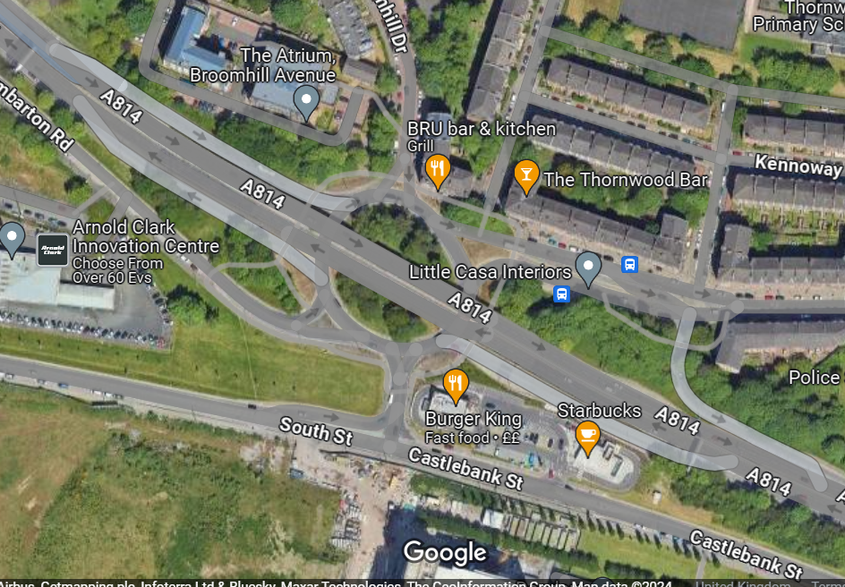

The existing walking route involves pedestrians crossing over the expressway off and on ramps and busy sections of road.  We would also like to take the opportunity to provide cycling facilities at this location to improve walking and cycling links in the area.

**Work to Date**

There have been various planning applications which promised the delivery of a large scale scheme that would address the local concerns, however, this is no longer in play and there has been lots of other development in the area which has not resulted in any mitigation measure or improvements for pedestrians.

Traffcom have investigated two locations for pedestrian crossings, which did not meet the current criteria due to pedestrian numbers.

On further review of the request for improvements, it was identified that a larger ‘’master plan’’ of the roundabout area would suit the needs of the community better, whilst this is a longer term plan, it would bring with it more benefits for the area.

**Future Works 2024**

I can advise that it would take 6 – 12 months to design and obtain any survey information.

Survey Information would include

* All road and footway levels, widths, condition and length
* Public Utility information (gas, water, electricity etc)
* Traffic and pedestrian surveys for the area
* Traffic modelling to assess the capacity of any proposed junction improvements

It is anticipated the design would be complete before the end of 2024 and this would allow us to apply for funding for year 2025-2026, to allow construction works to take place.

There would be no requirement for a consultant at this stage as Kevin has confirmed he has availability after April 2024.

Keeping in mind Derek is doing something in the background that may show improvements, but we would be better gearing up for Kevin’s team to undertake the design.

**How can the AP help?**

* Could £100K from the AP fund be provided to allow the design stage to be undertaken, this would allow us to fast track the project for implementation.
* The group will likely ask for interim measures, we anticipate £10K would allow the minor lining improvements to be undertaken at the roundabout.
* We do not think it would be best value to undertake any larger scale projects such as the installation of the crossings at this time, as this would result in the equipment having to be removed when construction works start.